“ One has often seen the fire awakened
from the old volcano that was thought too old… ”

“ Do not leave me “
Jacques Brel, Famous Belgian Singer and Composer



the Ember

la Braise asbl
« La Braise », in a few words...

The adventure of “La Braise” started with the opening of the Day Centre in August 1995.
The story goes on with different structures.


A. The Day Care Center :

The Day Care Centre “La Braise” accommodates 33 adults with acquired brain injuries following, for example, a traumatic brain injury, a stroke, anoxia, encephalopathy.
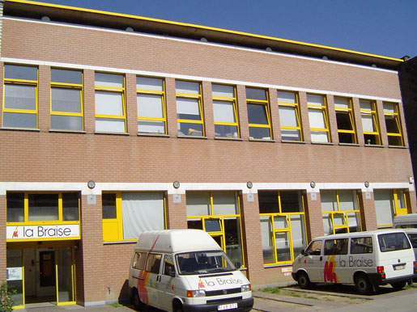
Since many years, the number of traumatic injured persons increases given the progress in reanimation and emergency medicine, in particular. People with cerebral injuries encounter sometimes many difficulties in everyday life. They might have disorders in memory, concentration, orientation in time and space, personality disorders, they may encounter behavioural problems, communication disorders, difficulties in dealing with their emotions and physical deficiencies. In a general way, severe brain injury involves disturbance in everyday life with effects on the person’s family, social and professional environment.
The main objective of “La Braise” day care centre is to allow each person to regain control of his/her possibilities. We accompany each person and suggest that he/she carries out a maximum of experiences him-herself.
To succeed in this objective, a multidisciplinary team is in charge of adults : teachers for special needs, occupational therapist, physiotherapist, speech therapist, neuropsychologist, social worker, neurologist, administrative and maintenance staff. Let us not forget the efficient help of volunteers. Every one aims at being coherent : a crucial criterion when trying to restructure persons in search of identity.
Our activities :
Most of the activities are organized in groups. Each person has the opportunity to take maximum advantage of situations in which they are confronted with pairs (who encounter the same difficulties).
The activities meet the needs and interests of the brain injured persons and are based, if possible, on the resources of the local community : everyday life, cultural, creative, physical and cognitive activities. For example : preparing a desert, going shopping, learning how to find the way in public
transport, going to the swimming pool, learning how to use word processing, singing, dancing, laughing, talking…
All the activities aim particularly at supporting autonomy and social integration, starting from the friendly and safe environment of “La Braise”.
In addition, adults have individual therapies according of their needs : speech therapy, physiotherapy, occupational therapy, cognitive rehabilitation, financial guidance and socio-administrative guidance.
The family is an essential partner. We include the close relatives within “La Braise”, as much as possible. They are invited to attend “family reports” and parties where families have the opportunity to meet.


B. Support Team :

With the experience of the Day Centre, we were convinced that Brussels lacked a service for the accompaniment of people with cerebral lesions. The Accompaniment Service opened on September 1998.
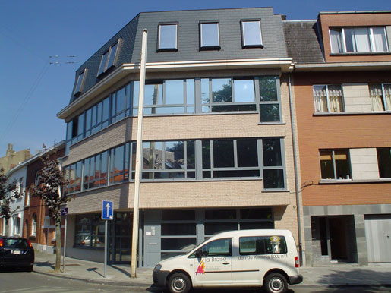
The main mission of this service is to meet patient’s needs for assistance in view gaining more autonomy and improving their quality of life.
The service provides information, assistance and support in order to help these adults in the activities and procedures of everyday life.

In particular :
- looking for leisure or occupational activities, education or training, employment or voluntary help ;
- helping in the search for housing ;
- proposing administrative follow-up or financial guidance ;
- informing the person of his/her rights ; helping in new training (like using a washing machine, a food processor).
The team also answers to the queries of close relatives and professionals involved in cerebral lesion.
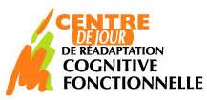
C. The Cognitive Rehabilitation Center :

The Cognitive Rehabilitation Centre “La Braise” follows since January 2002 traumatic brain injured adults and adults victims of stroke aged from 16 to 65 years.
The centre is intended only for adults still capable of evolution towards autonomy and social and professional reintegration. The adults follow rehabilitation programs adapted to their cognitive and behavioural difficulties.
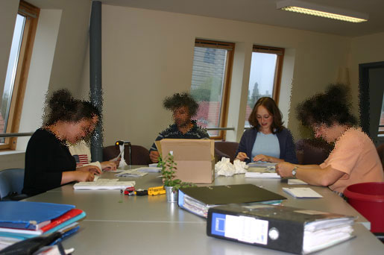
A multidisciplinary team is in charge of the adults : neuropsychologists, psychologist, teachers for special needs, occupational therapist, physiotherapist, speech therapist, neurologist, social worker, person in charge of reintegration, administrative staff and a director. Everyone aims at being coherent in his/her work with adults in the rehabilitation programs.
After an admission phase, the adult follows a 12 weeks test module aiming at assessing his/her cognitive and behavioural abilities. During this test period, the team assesses the adult’s ability to join a long-term rehabilitation program. This assessment is based on neuropsychological testing, ecological testing and evaluation at home.

If the test period is conclusive, the adult joins a cognitive and behavioural rehabilitation module, centered on family and social reintegration. If the objectives of this module are reached, the adult can join a module aiming at social and professional reintegration together with the search of activities favoring personal satisfaction or employment.
Activities, individual or in small group, aim at cognitive and behavioural rehabilitation.
The different activities are : cognitive, everyday life, cultural, creative and physical. For example : organizing a diary, taking care of one’s health, going shopping, learning to find the way in public transport and in the area, going to the swimming pool, learning how to use word processing and self-banking, training to converse…
Of course, within the various activities, the behavioural work is important. Adults learn how to adopt and maintain socially acceptable behaviours.
In addition to these activities, adults have individual therapies according to their needs and aiming to pursue the rehabilitation process : speech therapy, physiotherapy, occupational therapy, neuropsychology, financial and socio-administrative guidance, psychological support and work with
the person in charge of social integration.
Each adult is assessed systematically and continuously during his/her rehabilitation program. If no significant improvement appears within 6 months, the rehabilitation program stops and the adult is redirected. The maximum duration of these rehabilitation modules is 3 years.
Working as a network is a key factor in the success of rehabilitation work. We favour, as much as possible, contacts with other institutions that have intervened (or still do) with the brain injured adults.
The family plays an essential role in the rehabilitation work. We ask close relatives a commitment : they have to attend “family reports” on a regular basis and all meetings relating to the adult’s evolution.

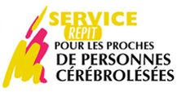
D. Respite Service :

Organized since May 2009, Respite Service sustains the relatives of severe brain injured adults who depend all the time on their relatives. We offer punctual respite’s moments : twice a week few hours. The relatives can take time for themselves to rest or to different activities like shopping, medical appointment, leisures….
We organize the respite at the home of the brain injured adult or outside.



E. Residential Care Center :

A Residential Care Center for acquired brain injured people should be built in Brussels in the next few years.

Indeed, some adults can not live alone and depend on their family due to their complex and multiple sequelae that limit their autonomy. However, families grow old and worry about the future.
Who will take care of their disabled family member when they are no longer there ?
This center will house 15 adults and provide the necessary support to enable them to have accommodation and a good quality of life despite their high level of dependence.
We are looking for funds. Indeed, government subsidies will be well below the reality of a suitable offering quality accommodation construction.

